**JAVA PROGRAMMING QUESTION**

1.package project1;

public class PalindromeCheck {

public static void main(String[] args)

{

String input ="madam";

String reversed = new StringBuilder(input).reverse().toString();

if (input.equals(reversed)) {

System.***out***.println("The given string is a palindrome.");

} else {

System.***out***.println("The given string is not a palindrome.");

}

}

}

OUTPUT:

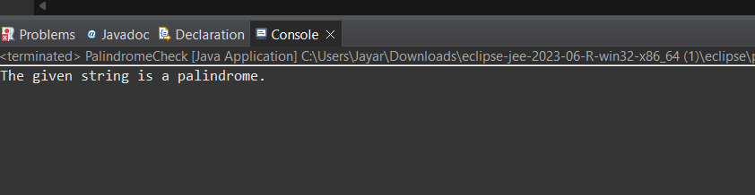

2. package project1;

import java.util.Scanner;

public class ReverseString {

public static void main(String[] args)

{

Scanner scanner = new Scanner(System.***in***);

System.***out***.print("Enter a string: ");

String input = scanner.nextLine();

String reversed = "";

for (int i = input.length() - 1; i >= 0; i--)

{

reversed += input.charAt(i);

}

System.***out***.println("Reversed string: " + reversed);

}

}

OUTPUT:

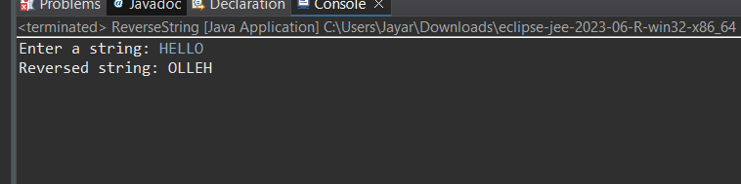

3.package project1;

import java.util.Scanner;

public class NumberPattern {

public static void main(String[] args) {

Scanner scanner = new Scanner(System.***in***);

System.***out***.print("Enter the number of rows: ");

int rows = scanner.nextInt();

int number = 1;

for (int i = 1; i <= rows; i++) {

for (int j = 1; j <= i; j++) {

System.***out***.print(number +" ");

number++;

}

System.***out***.println();

}

}

}

OUTPUT:

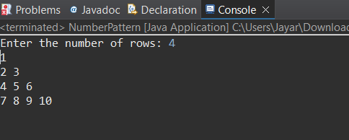

4. package project1;

import java.util.Scanner;

public class DiamondPattern {

public static void main(String[] args) {

Scanner scanner = new Scanner(System.***in***);

System.***out***.print("Enter the number of rows: ");

int rows = scanner.nextInt();

for (int i = 0; i < rows / 2; i++) {

for (int j = 0; j < i; j++) {

System.***out***.print(" ");

}

System.***out***.print("*");

for (int j = 0; j < rows - 2 - 2 * i; j++) {

System.***out***.print(" ");

}

System.***out***.println("*");

}

for (int i = 0; i < rows / 2; i++) {

System.***out***.print(" ");

}

System.***out***.println("*");

for (int i = rows / 2 - 1; i >= 0; i--) {

for (int j = 0; j < i; j++) {

System.***out***.print(" ");

}

System.***out***.print("*");

for (int j = 0; j < rows - 2 - 2 * i; j++) {

System.***out***.print(" ");

}

System.***out***.println("*");

}

}

}

OUTPUT:

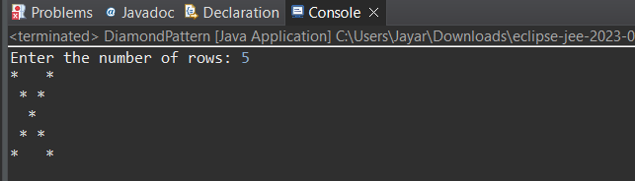

5. package project1;

import java.util.Scanner;

public class GradingSystem {

public static void main(String[] args) {

Scanner scanner = new Scanner(System.***in***);

System.***out***.print("Enter the student's mark: ");

int mark = scanner.nextInt();

String grade;

if (mark > 100) {

grade = "Invalid Input";

} else if (mark == 100) {

grade = "S";

} else if (mark >= 90) {

grade = "A";

} else if (mark >= 80) {

grade = "B";

} else if (mark >= 70) {

grade = "C";

} else if (mark >= 60) {

grade = "D";

} else if (mark >= 50) {

grade = "E";

} else {

grade = "F";

}

System.***out***.println(grade);

}

}

OUTPUT:

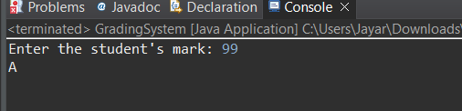

6. package project1;

import java.util.Scanner;

public class HotelTariff {

public static void main(String[] args) {

Scanner scanner = new Scanner(System.***in***);

System.***out***.print("Enter the month number (1-12): ");

int month = scanner.nextInt();

System.***out***.print("Enter the room rent per day: ");

double roomRentPerDay = scanner.nextDouble();

System.***out***.print("Enter the number of days stayed: ");

int daysStayed = scanner.nextInt();

boolean isPeakSeason = false;

switch (month) {

case 4: case 5: case 6: case 11: case 12:

isPeakSeason = true;

break;

default:

isPeakSeason = false;

break;

}

if (isPeakSeason) {

roomRentPerDay *= 1.20;

double totalTariff = roomRentPerDay * daysStayed;

System.***out***.printf("Hotel tariff to be paid: %.2f%n", totalTariff);

}

}

}

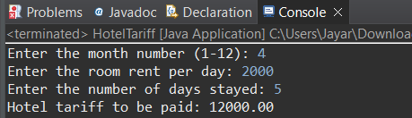OUTPUT:

7.package project1;

import java.util.Scanner;

public class LargestNumber {

public static void main(String[] args) {

Scanner scanner = new Scanner(System.***in***);

System.***out***.print("Enter the first number: ");

int num1 = scanner.nextInt();

System.***out***.print("Enter the second number: ");

int num2 = scanner.nextInt();

System.***out***.print("Enter the third number: ");

int num3 = scanner.nextInt();

int largest = num1;

if (num2 > largest) {

largest = num2;

}

if (num3 > largest) {

largest = num3;

}

System.***out***.println("The largest number is: " + largest);

}

}

OUTPUT:

